**Making phantoms**

Top Layer (Slow Phantom): 650mL water (tap water), 350 mL glycerol, 100 mL 20% I.L. 0.6mL Ink

Bottom Layer (Fast Phantom): 1350 mL water, 55mL I.L. 0.84 mL ink

**Characterization**

Slow Phantom:

**NIRS**

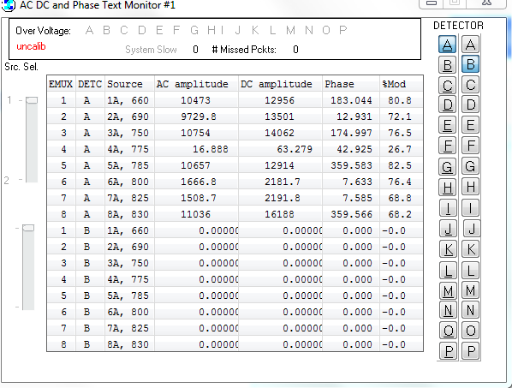

Gain: -995

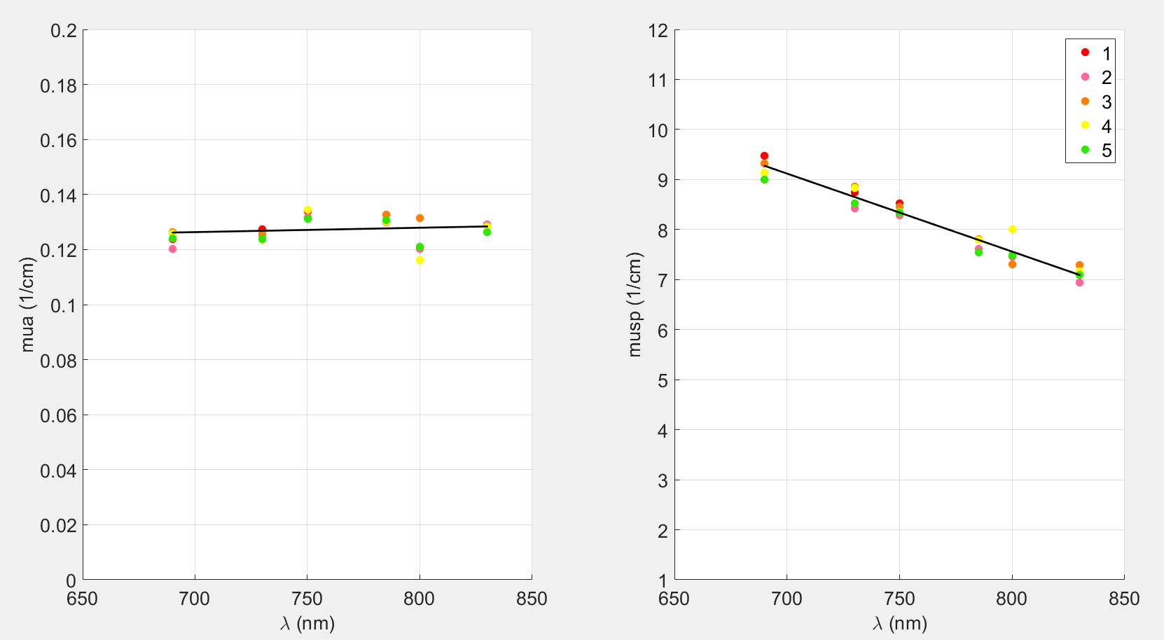

mua=0.1287 , musp=6.7790

**HWC**

Temp:

Pre: 21.1 C

Post: 21.0 C

15mm:

Intensity: 155~175 kHz

Int time: 1000 ms

20mm:

Intensity: 45~50 (Adjusted laser to increase intensity)

Int time: 3000 ms

**SWC**

Temp:

Pre: 21.0 C

Post: 21.3 C

ABPAcqRate:125

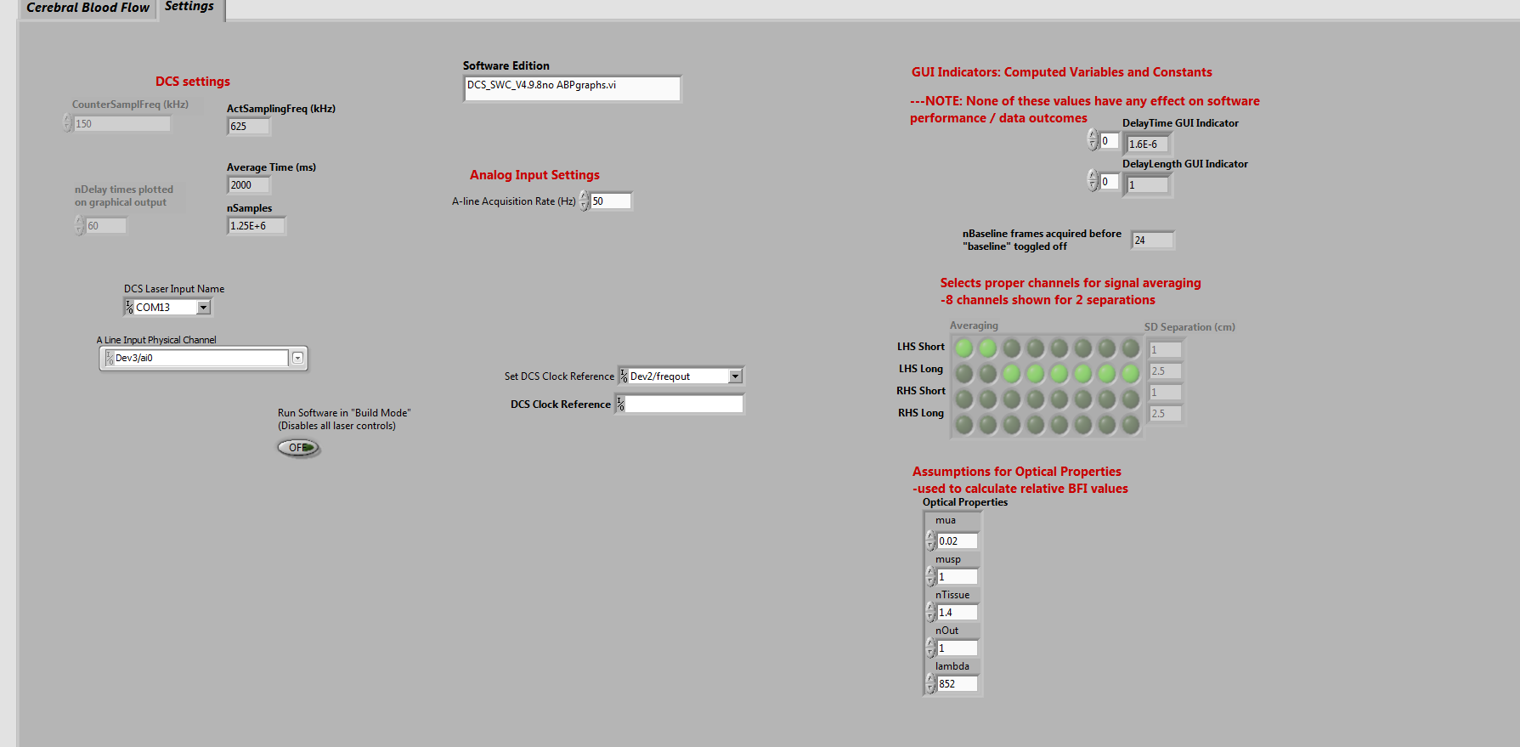

15mm:

Intensity: 150 kHz (adjusted laser to decrease intensity)

DataAcqRate: 1Hz

20mm:

Intensity:~41 kHz

DataAcqRate: 0.5

Fast Phantom:

**NIRS**

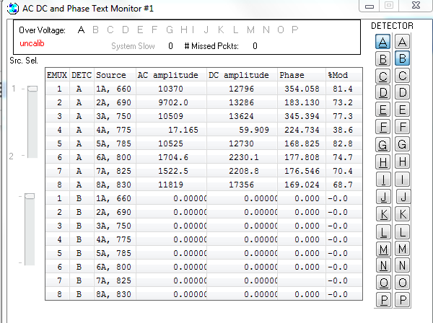

Gain: -995

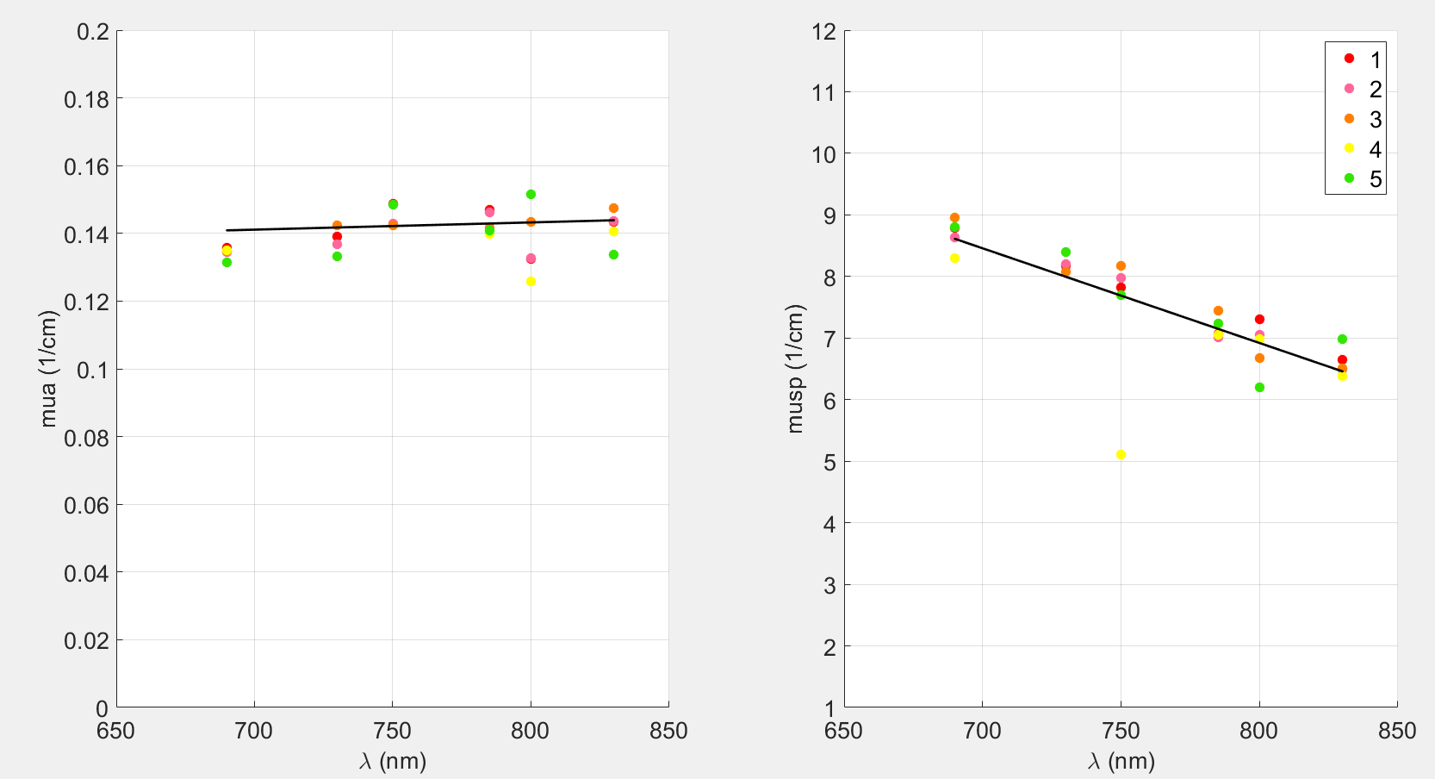

mua= 0.1443, musp= 6.1501

**HWC**

Temp:

Pre: 19.7 C

Post: 19.9 C

15mm:

Intensity: ~200 kHz

Int time: 1000 ms

20mm:

Intensity:~48 kHz

Int time: 5000 ms

**SWC**

Temp:

Pre: 19.9 C

Post: 20.1 C

ABPAcqRate: 125 Hz

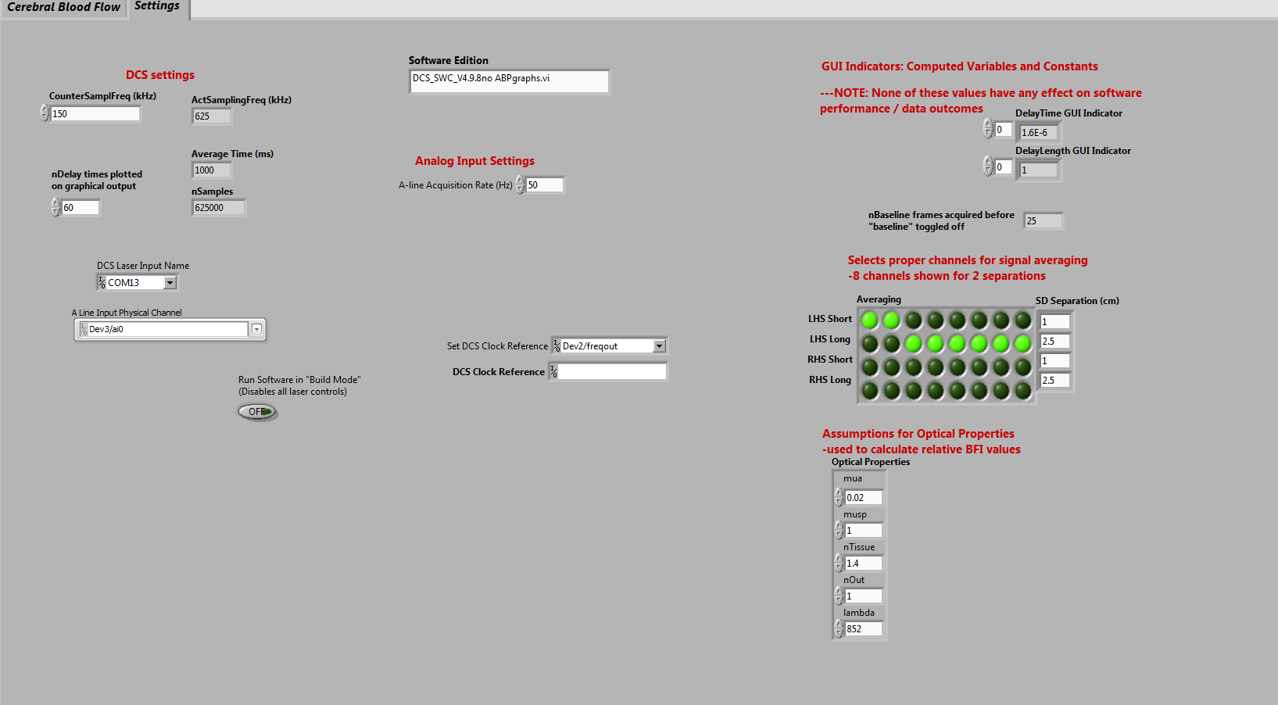

15mm:

Intensity: ~202 kHz

DataAcqRate: 1 Hz

20mm:

Intensity: ~49

DataAcqRate: 0.5

Two Layer Phantom

**HWC**

Temp Pre:

top:

bot:

Temp Post:

top: 21.5 C

bot: 21.2 C

Intensity:

Int time: 13000ms

**SWC**

Temp Pre:

top: 21.5 C

bot: 21.2 C

Temp after Discard 20 measurement:

top:21.2

bot:21.1

Temp post:

top:21.0

bot:20.8

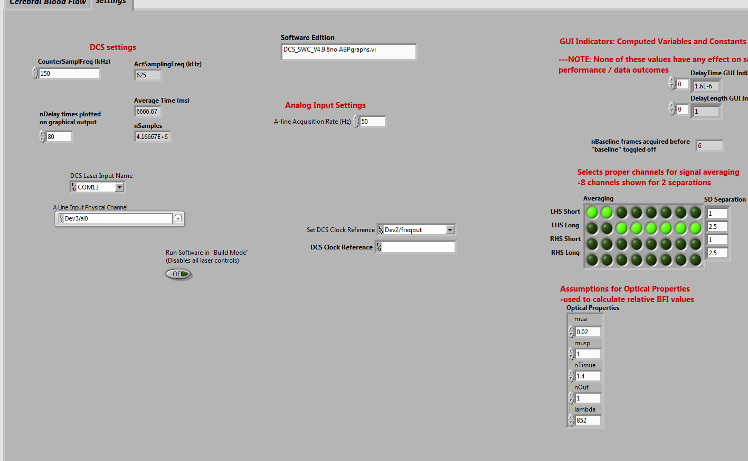

Intensity:

DataAcqRate: 0.15